**Custom Workflow Step with dialog in aem**

***We sometimes need to capture data during a workflow step in AEM and this can easily be achieved with out of the box components. Furthermore, we can choose if the captured data is stored on page properties or on the workflow’s work item.***

***Requirement:***

***There is a one component in that I have fields ,If I give any data in the fields that data need to be added in the workflow level properties.***

***Solution:***

***First create the component , component should have cq:editconfig node in that node must have the cq:formparameter node***

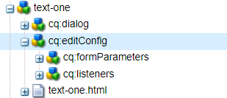

***After creating the component , we need enable our component group in all section then only we can add our component in workflow .***

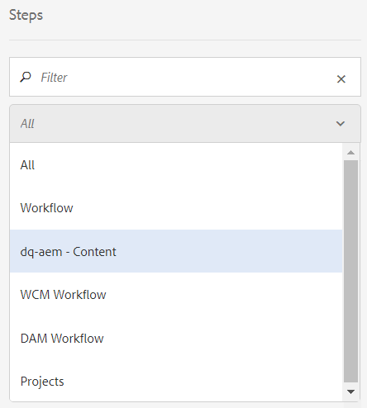

***For enabling component group in ‘All’ section ,we need to go advance tab in that by default we have libs path is there ,we don’t do any changes in the libs that why we have to ovlerly to apps from there we have to add the component – group of our’s like below .***

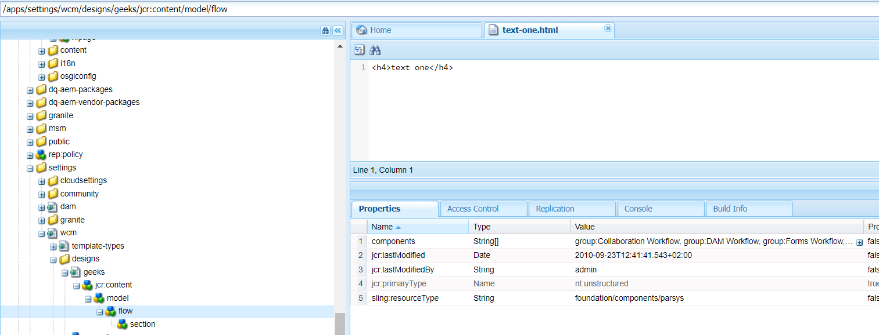

***After that we have to double click on the components to add the component group it should as below image  
  
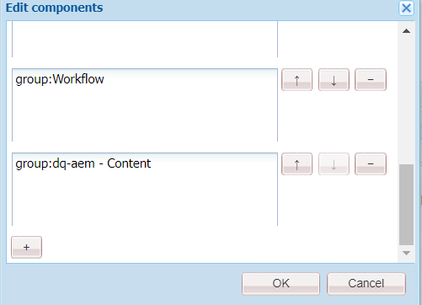***

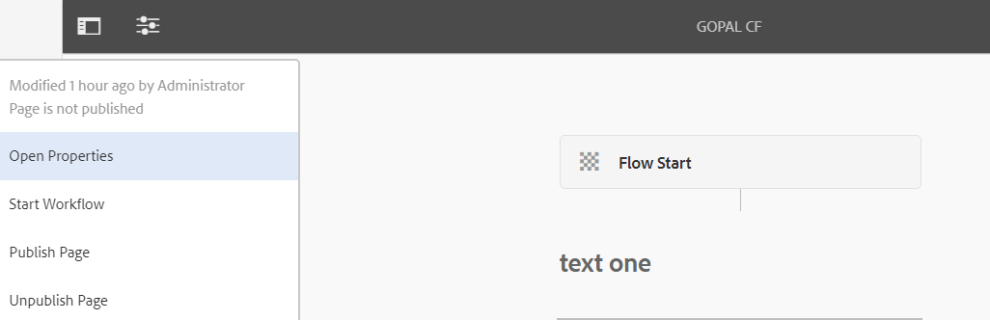

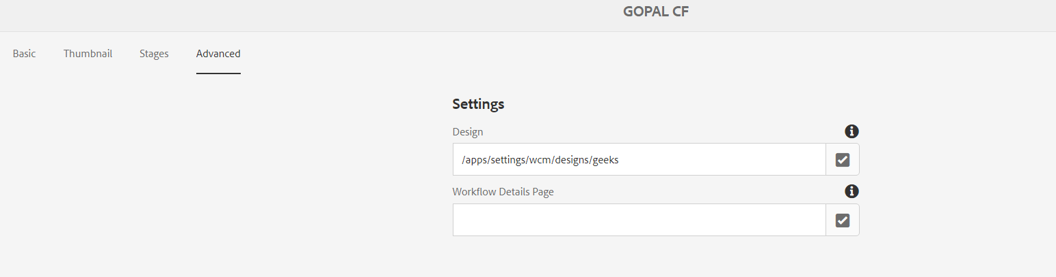

***In the next step open the dialog box and give the input and sync it , It directly added workflow page.***

